# Huawei Cloud Server Configuration

## Login

1. Go to <https://console.huaweicloud.com>
2. Click on “IAM User” for login.
3. Enter the login details to login. 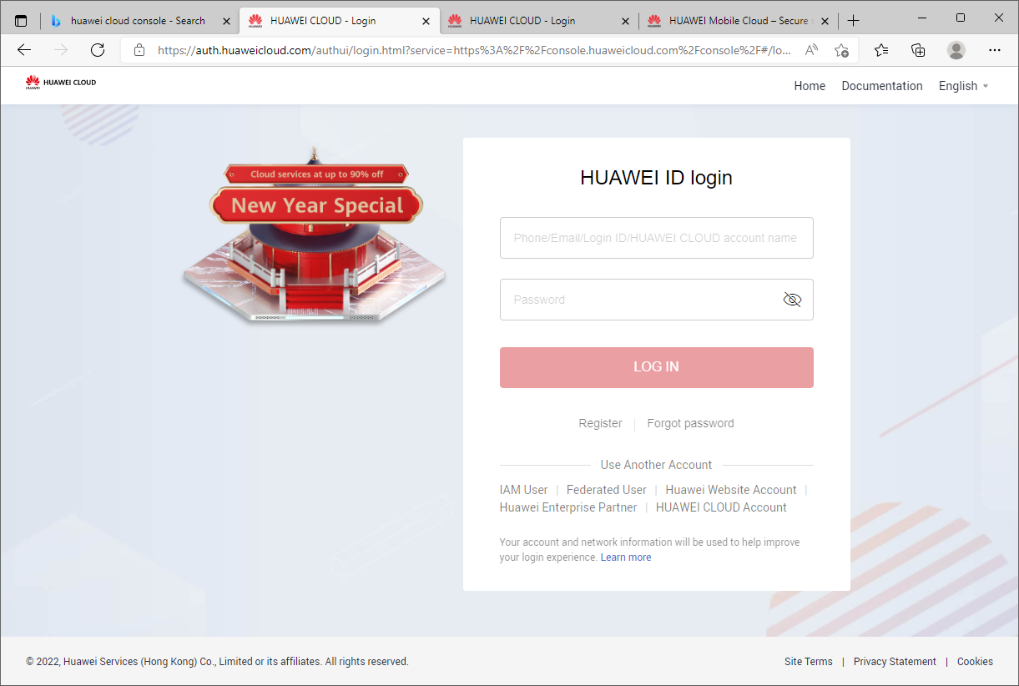

page23image14735360page23image14735552

Creating VPC

1. Select on “Service List” on the left side of the web page. Click on “Virtual Private Cloud” under “Networking”. 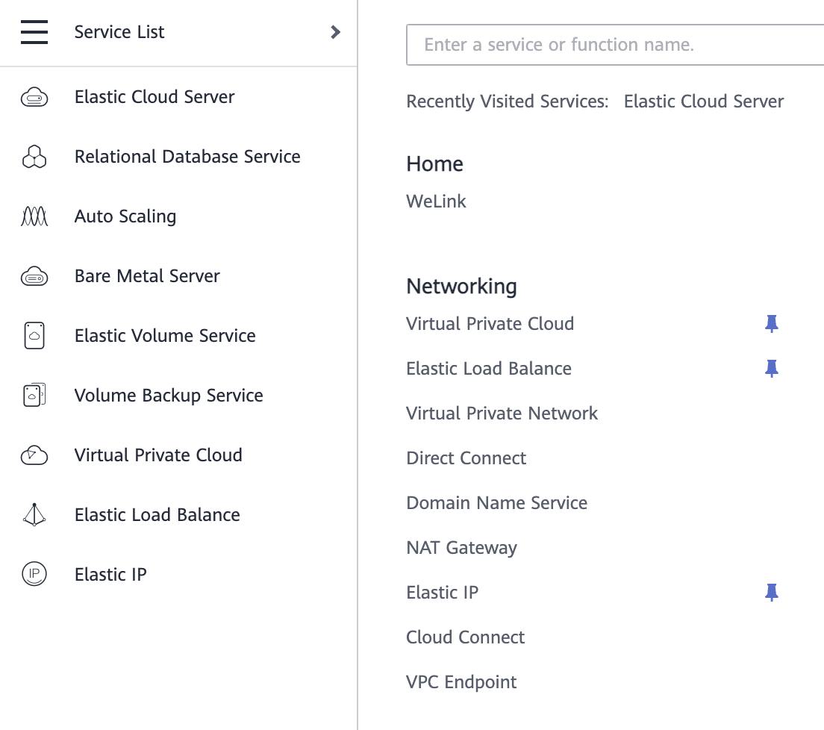
2. Click on “Create VPC”.

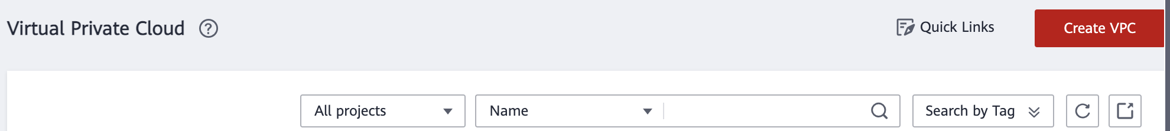

1. Fill in/select the options accordingly:  
   Region: AP-Singapore  
   Name: a custom name  
   Retain the default settings for other parameters.
2. Click on “Create Enterprise Project”

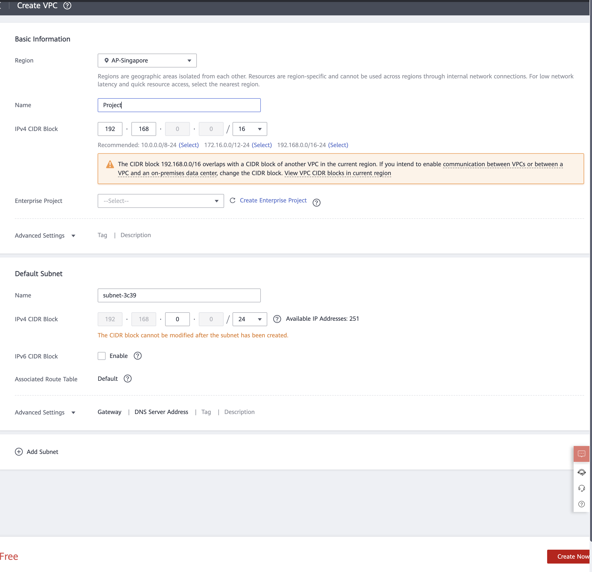

1. Click on “Create Enterprise Project”

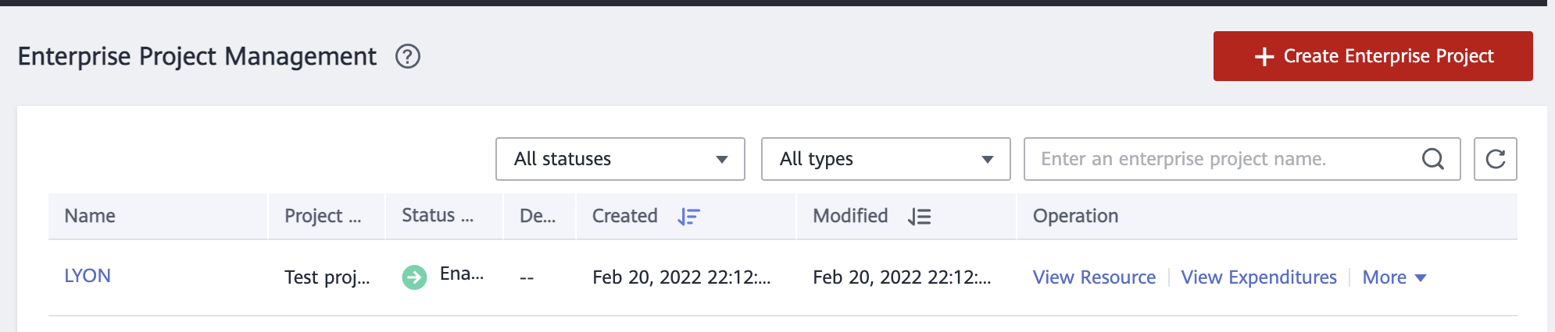

1. Select “Test Project” for the Project Type and enter the name of the project.
2. Click OK.

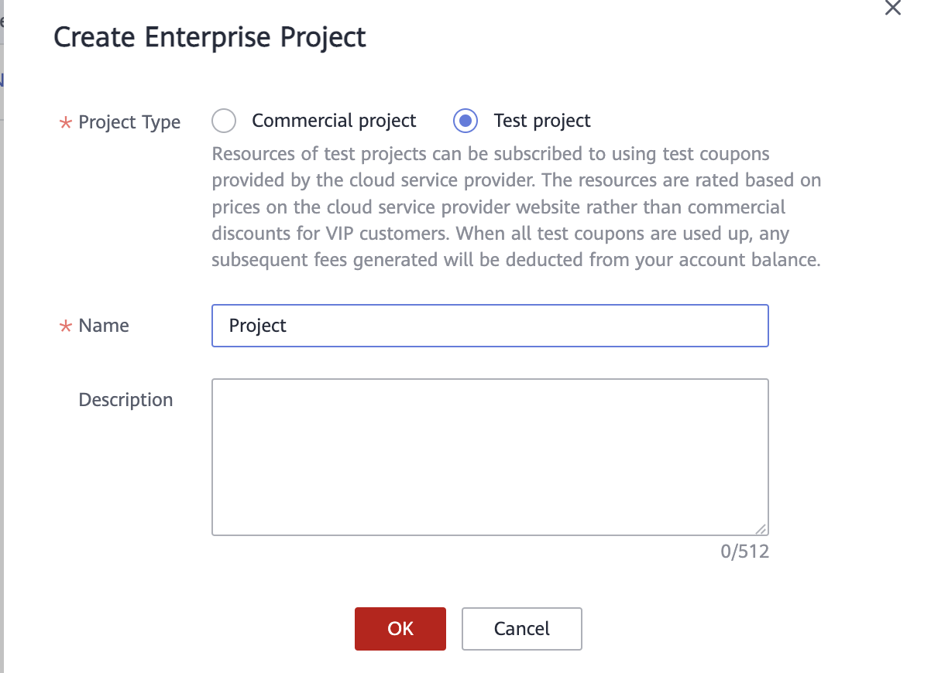

1. Return to the Create VPC Page. Under the Enterprise Project, select the project created just now.



1. Click on “Create Now” on the bottom right of the page to create the VPC. The VOC is now created.

Creating ECS

1. Select on “Service List” on the left side of the web page. Click on “Elastic Cloud Server” under “Compute”. 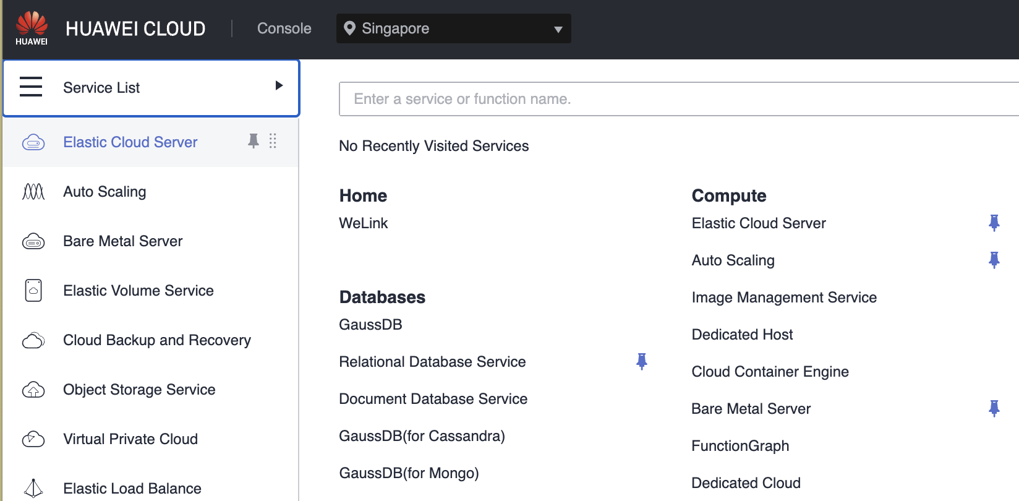
2. Click on “Buy ECS”

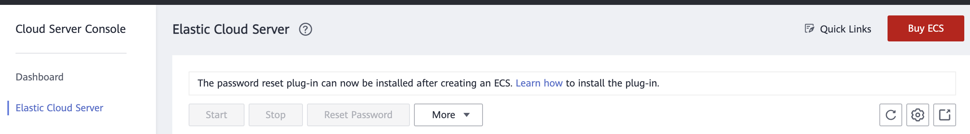

1. Select the following options:  
   Billing Mode: Pay-per-use  
   Region: AP-Singapore  
   AZ: Random  
   CPU Architecture: x86  
   Specifications: Select desired computing specifications  
   Image: Public Image, Select Ubuntu, Ubuntu 20.04 server 64bit(40GB)
2. Leave the rest as default. Click on “Next: Configure Network” to continue

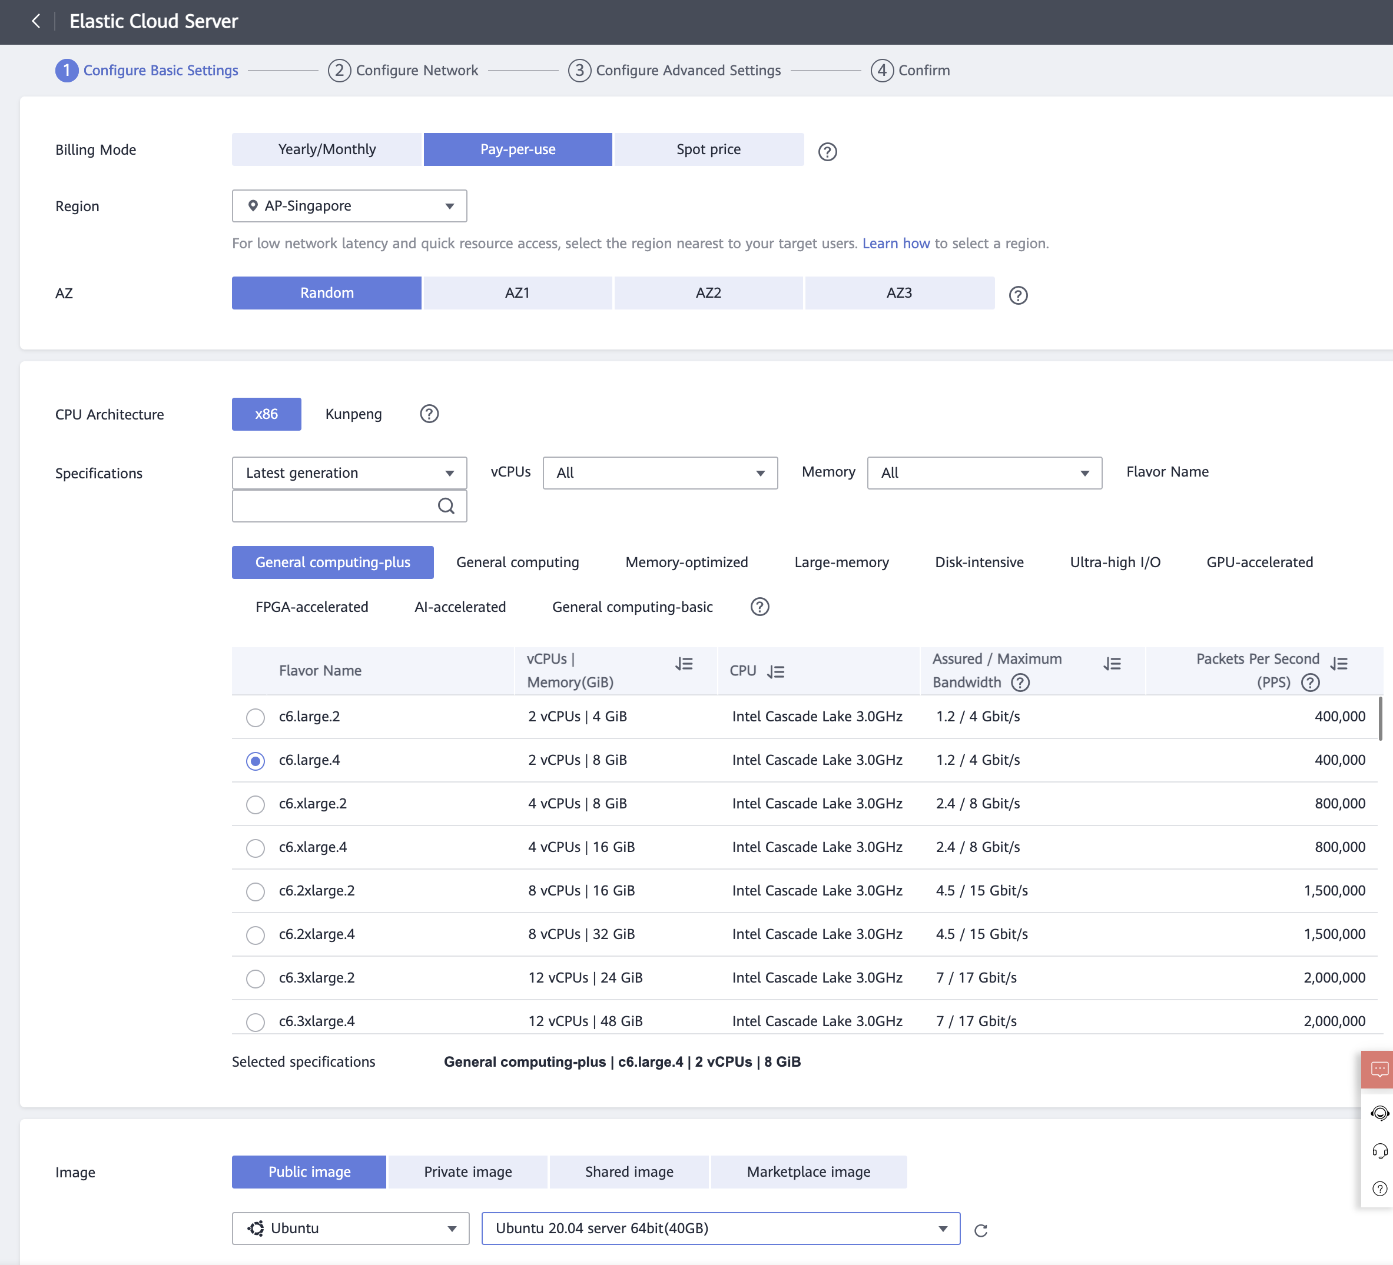

1. Configure as follows:  
   Network: Choose the created VPC.   
   Extension NIC: Retain the default settings.   
   Security Group: Retain the default settings.   
   EIP: Not required
2. Click on “Next:

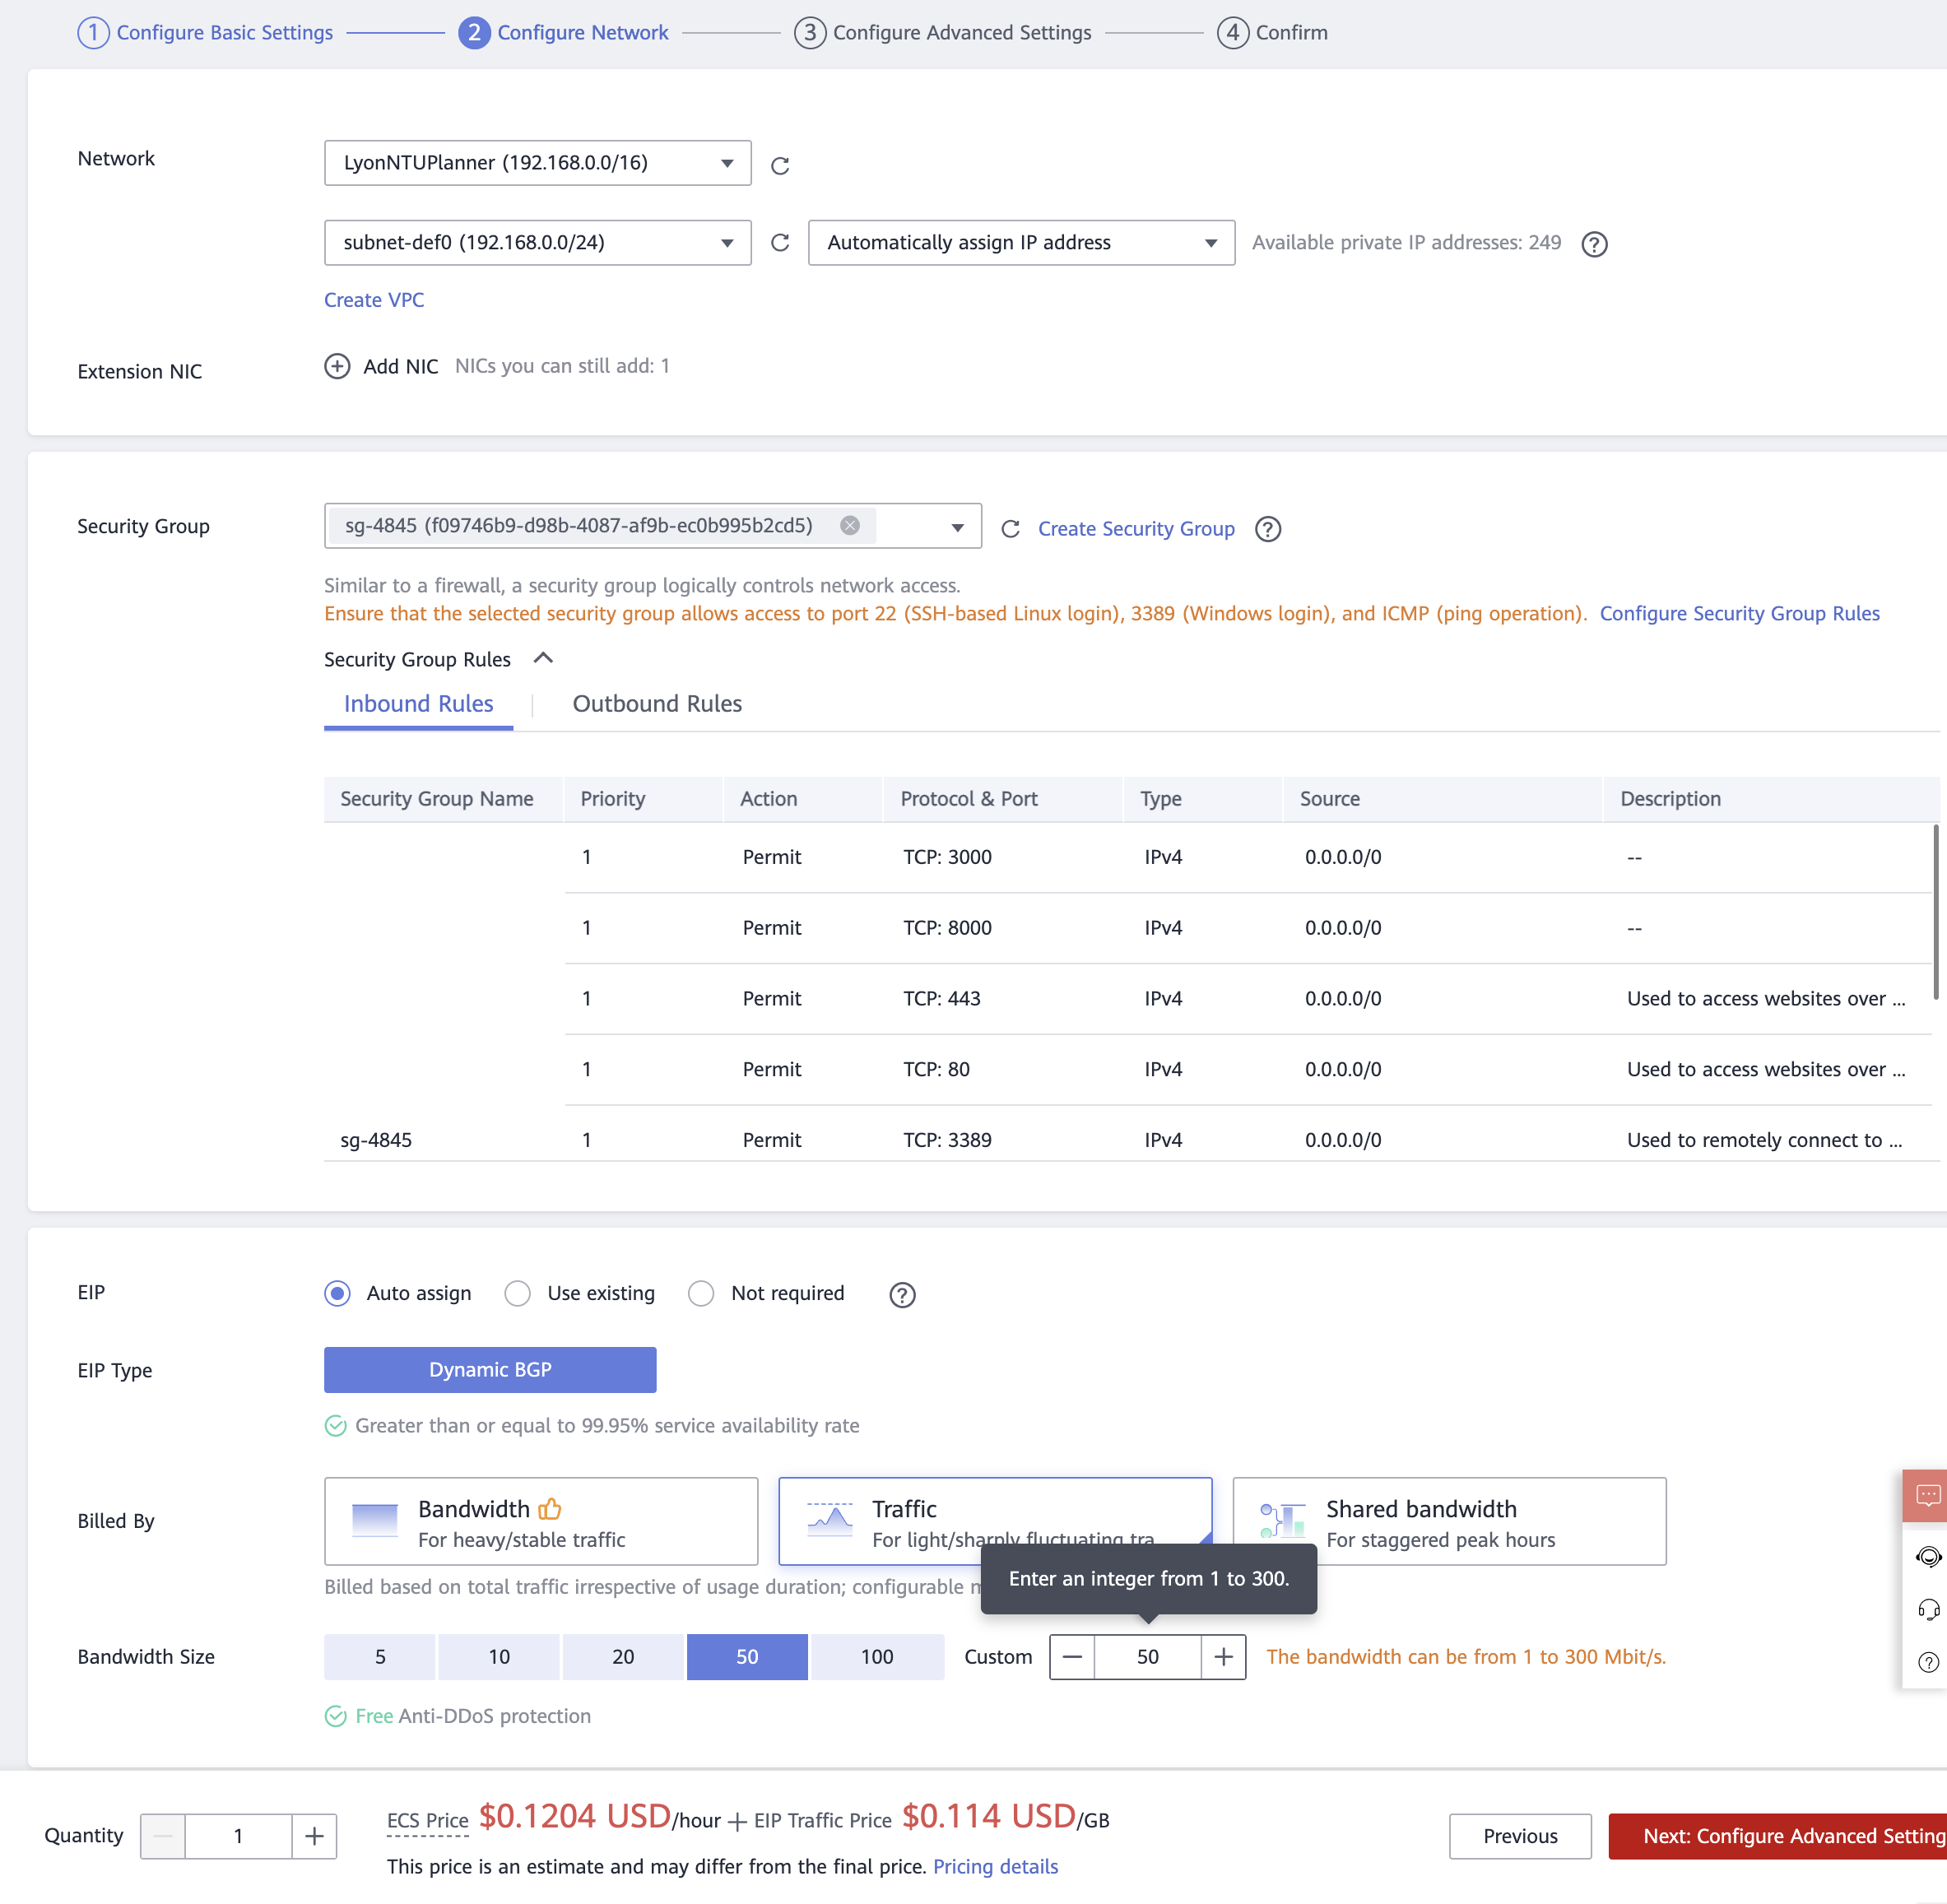

1. Configure as follows:  
   ECS Name: Set as required.  
   Login Mode: Password  
   Password: Set as required.  
   Cloud Backup and Recovery: Not required  
   ECS Group (Optional): Retain default settings.   
   Advanced Options: Retain the default settings.  
   Click on “Next: Confirm” on the bottom right of the page.

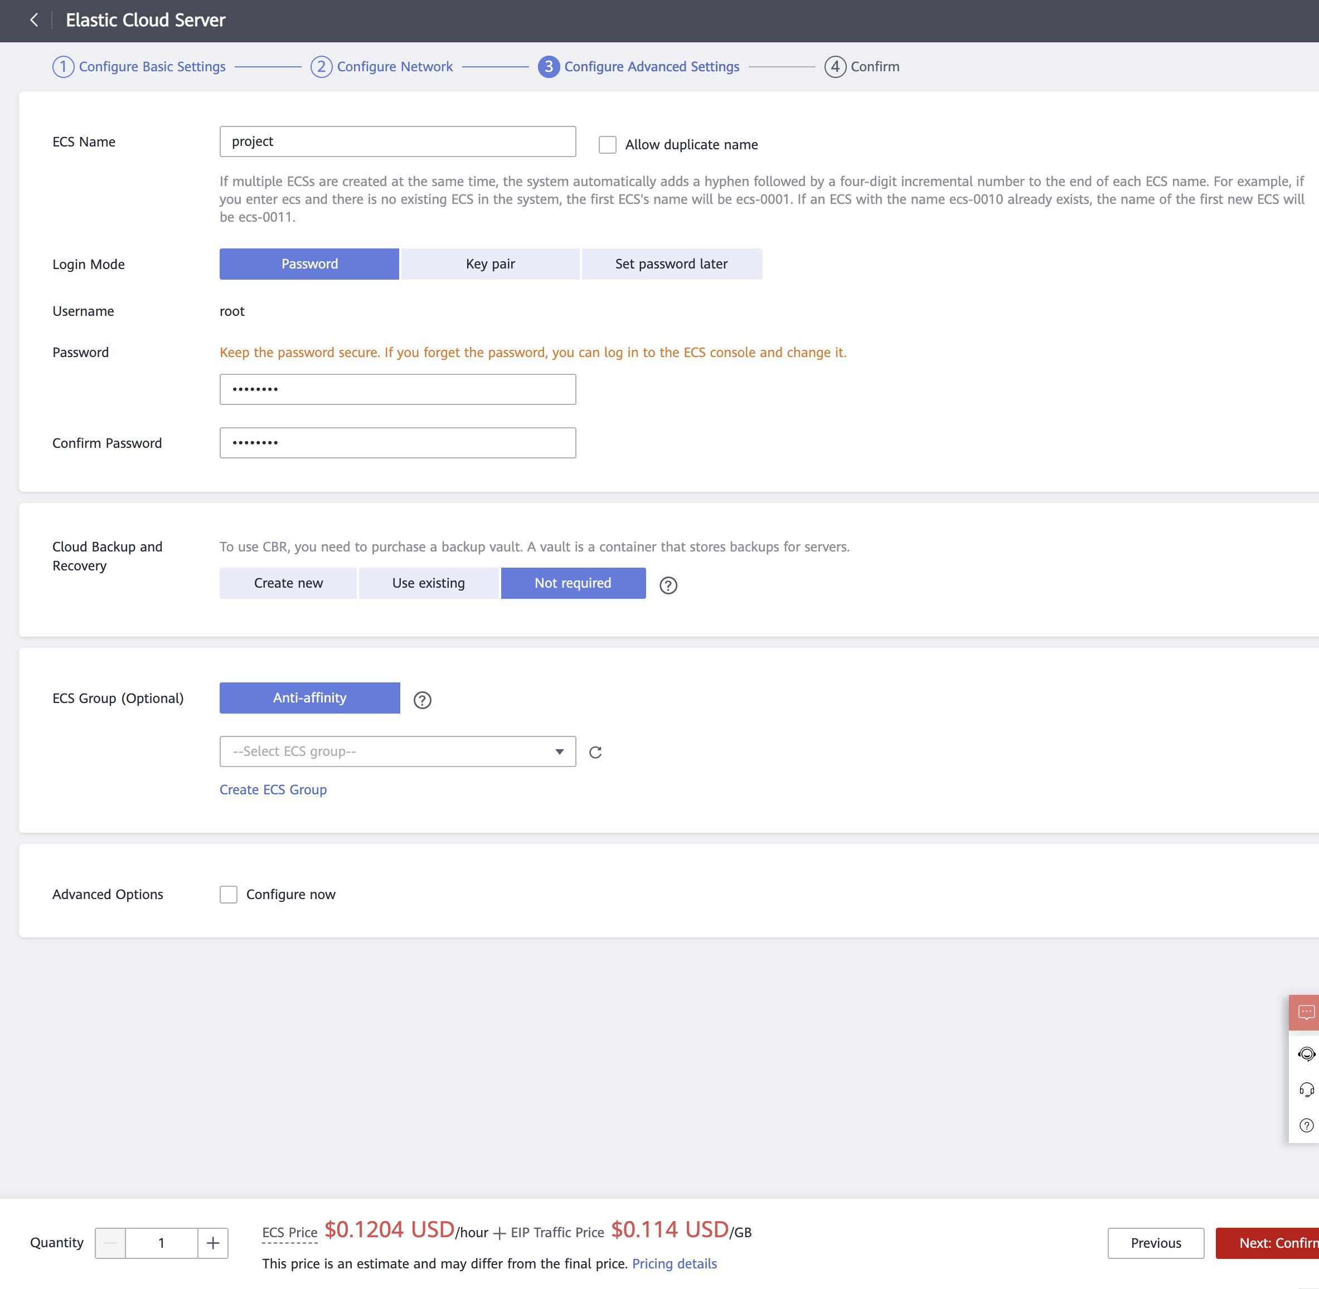

1. Select the enterprise project , Agree to the SLA and Image Disclaimer and click on “Submit”

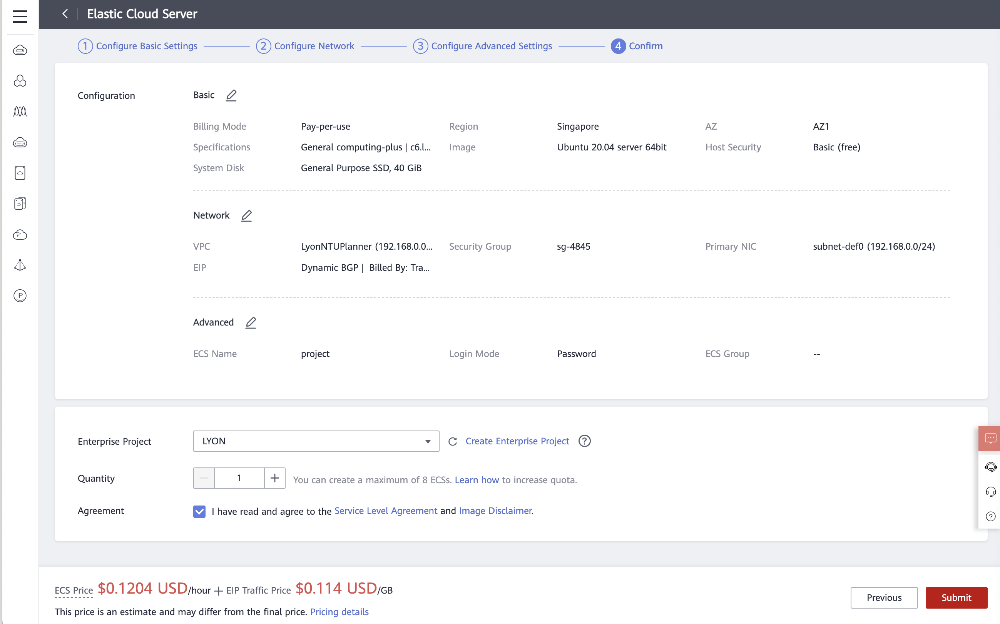

## Starting the New ECS

1. On the Elastic Cloud Server Page, click and select on the created ECS.

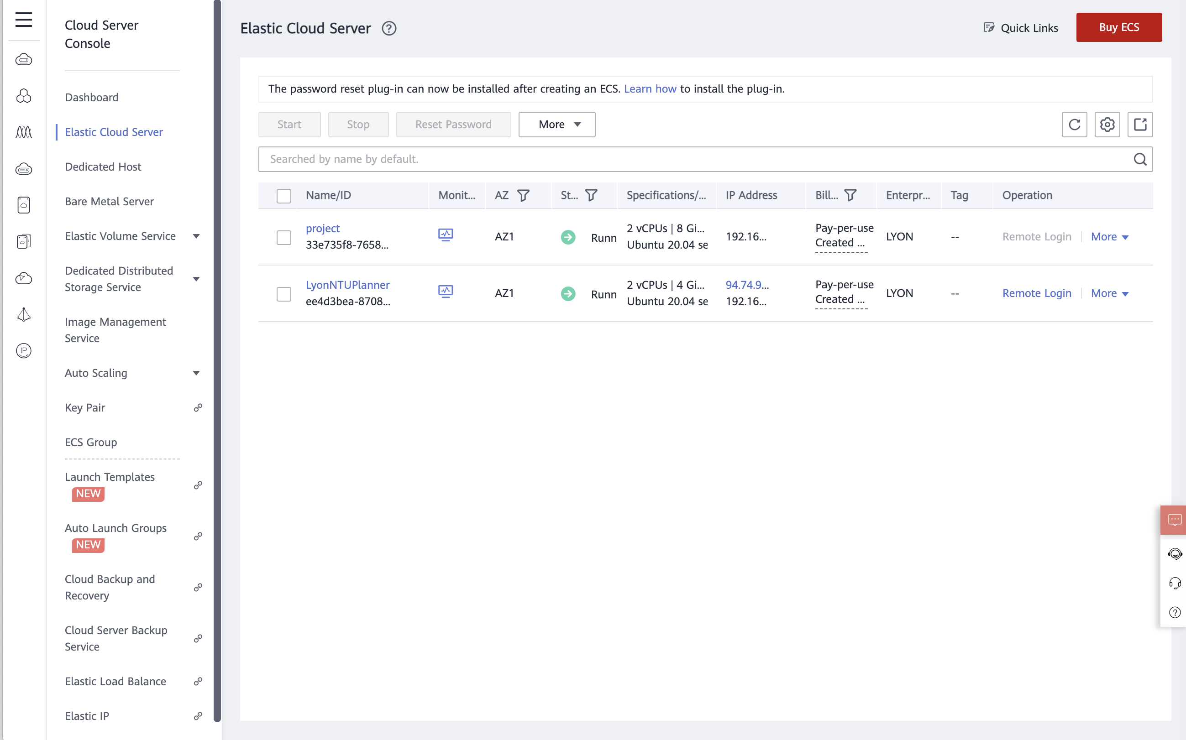

1. If the server is not started, click on start. Else, click on “Remote Login”

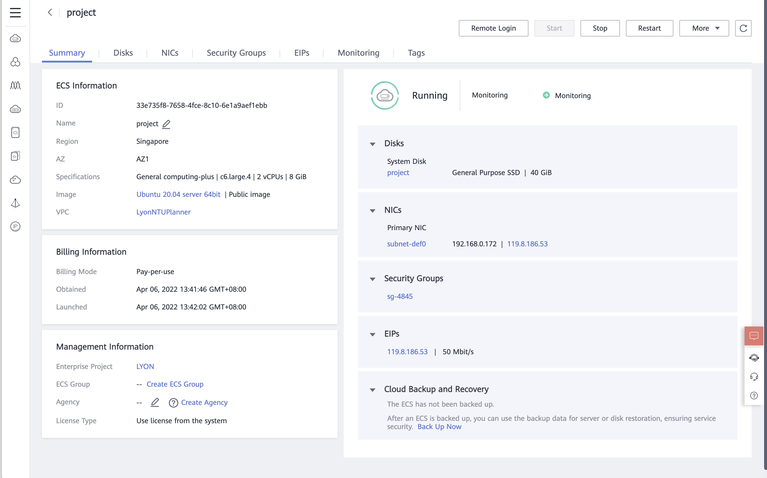

## Configuring the Ubuntu server

1. Enter the username, “root”  
   Enter the root password



1. Enter the following commands to install GUI for Ubuntu:  
   sudo apt-get update  
   sudo apt-get install ubuntu-gnome-desktop -y
2. After the installation is done, run the following command:  
   sudo shutdown -r now
3. Click on “Next” on the welcome screen.

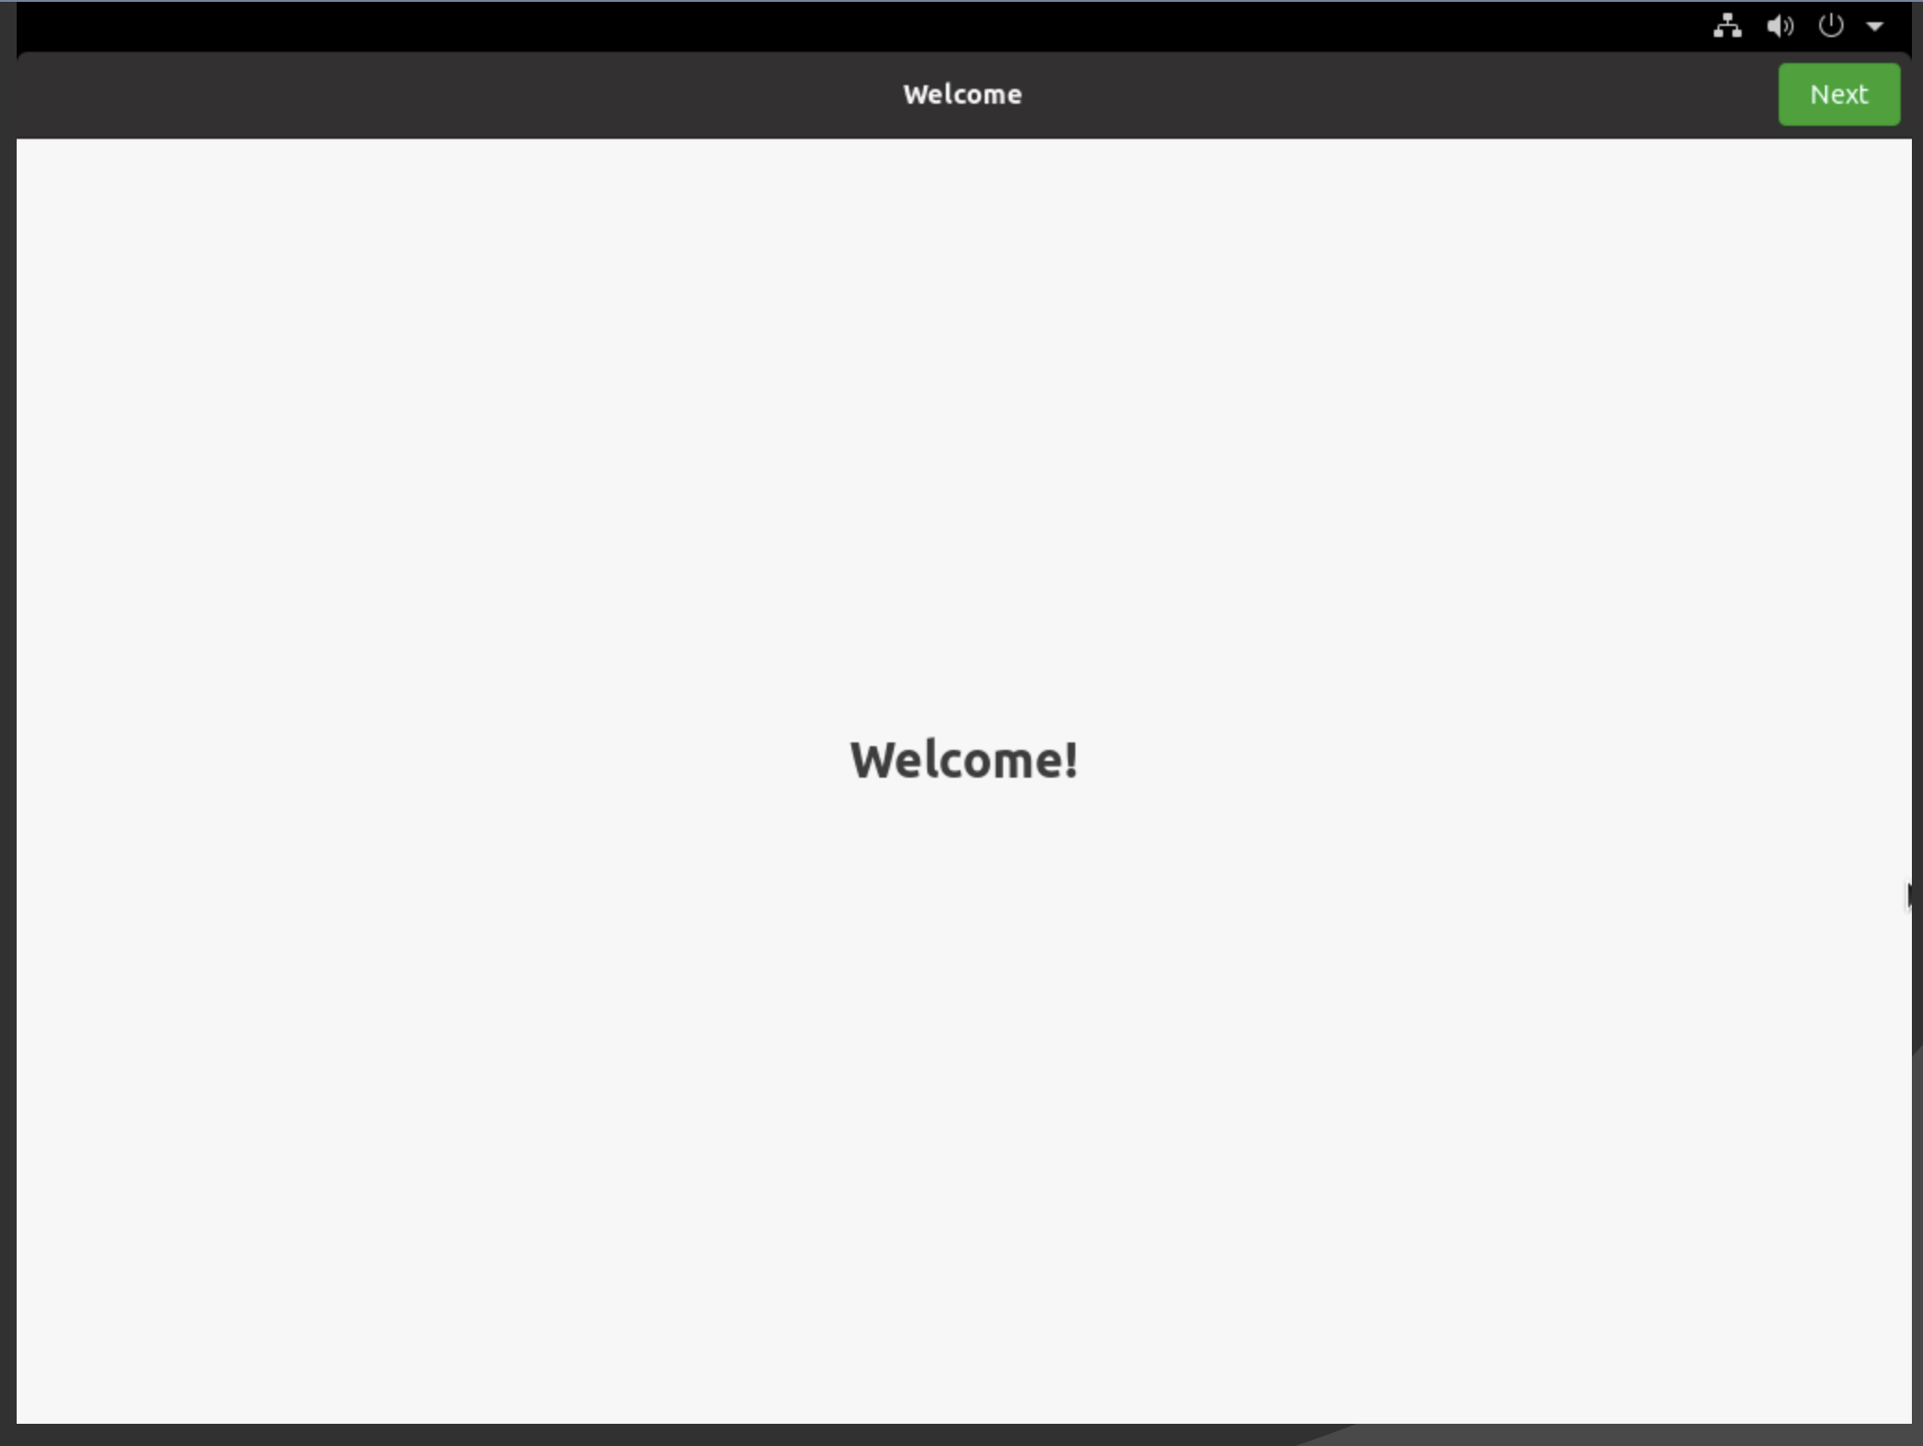

1. Click on next for Typing.

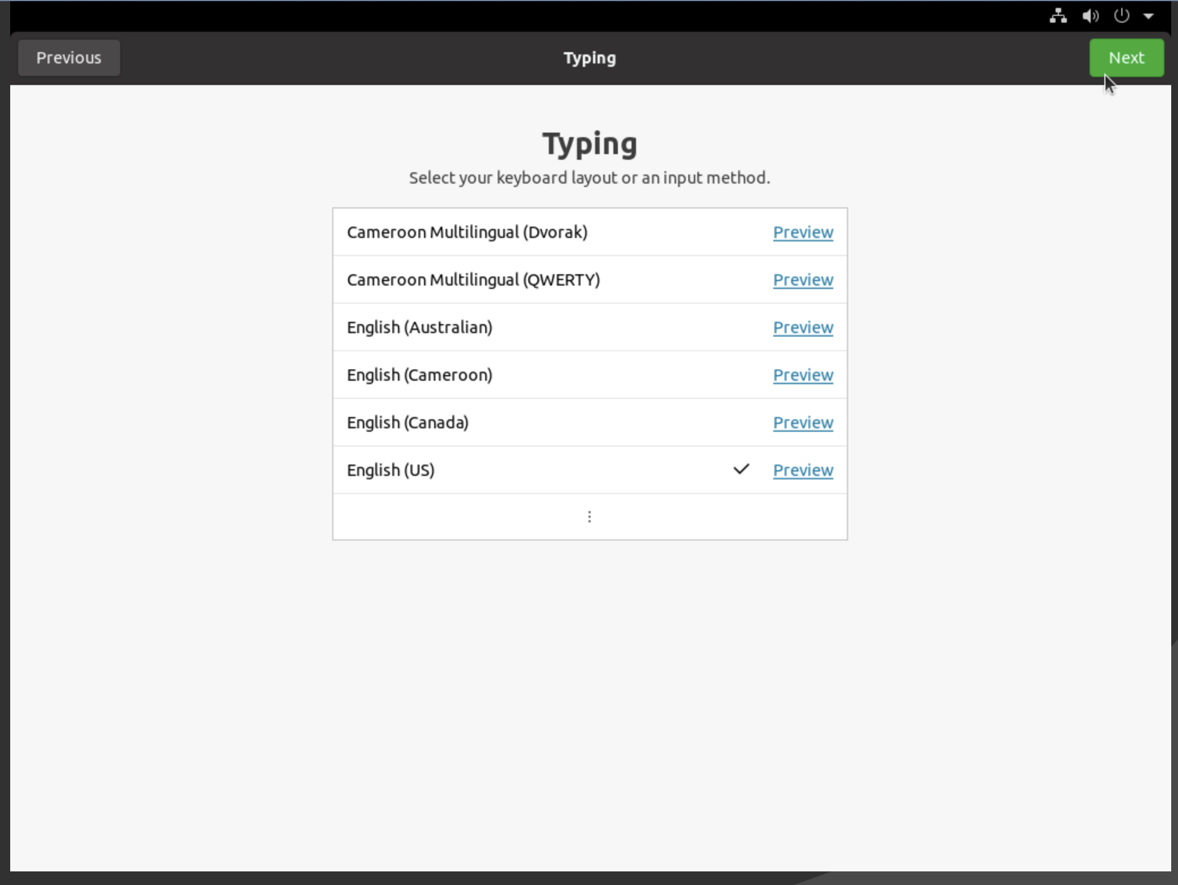

1. Click on “Next”” for Privacy.

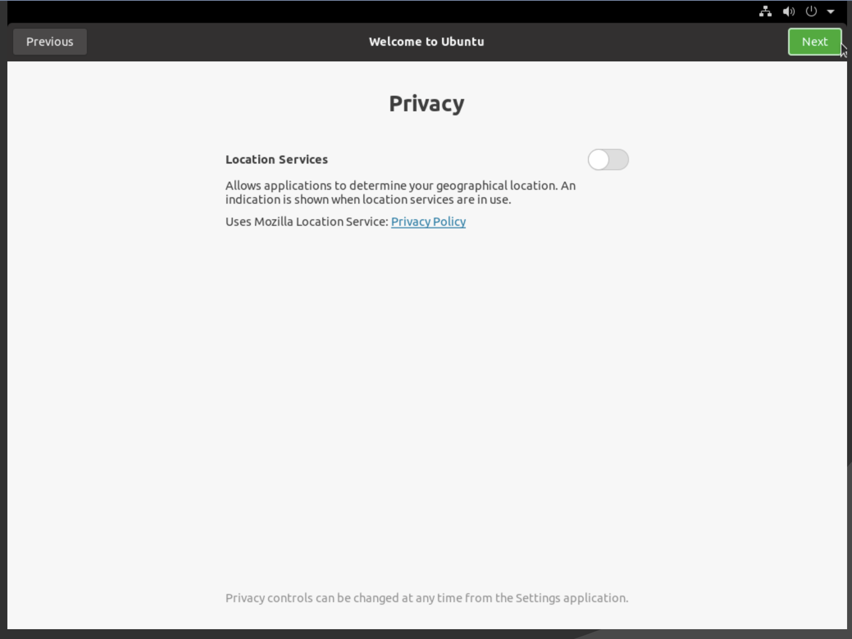

1. Select desired timezone and click “Next”

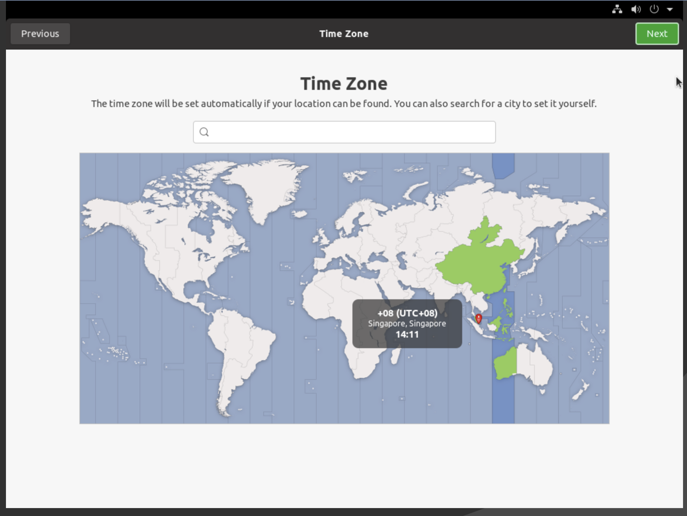

1. Skip this page. 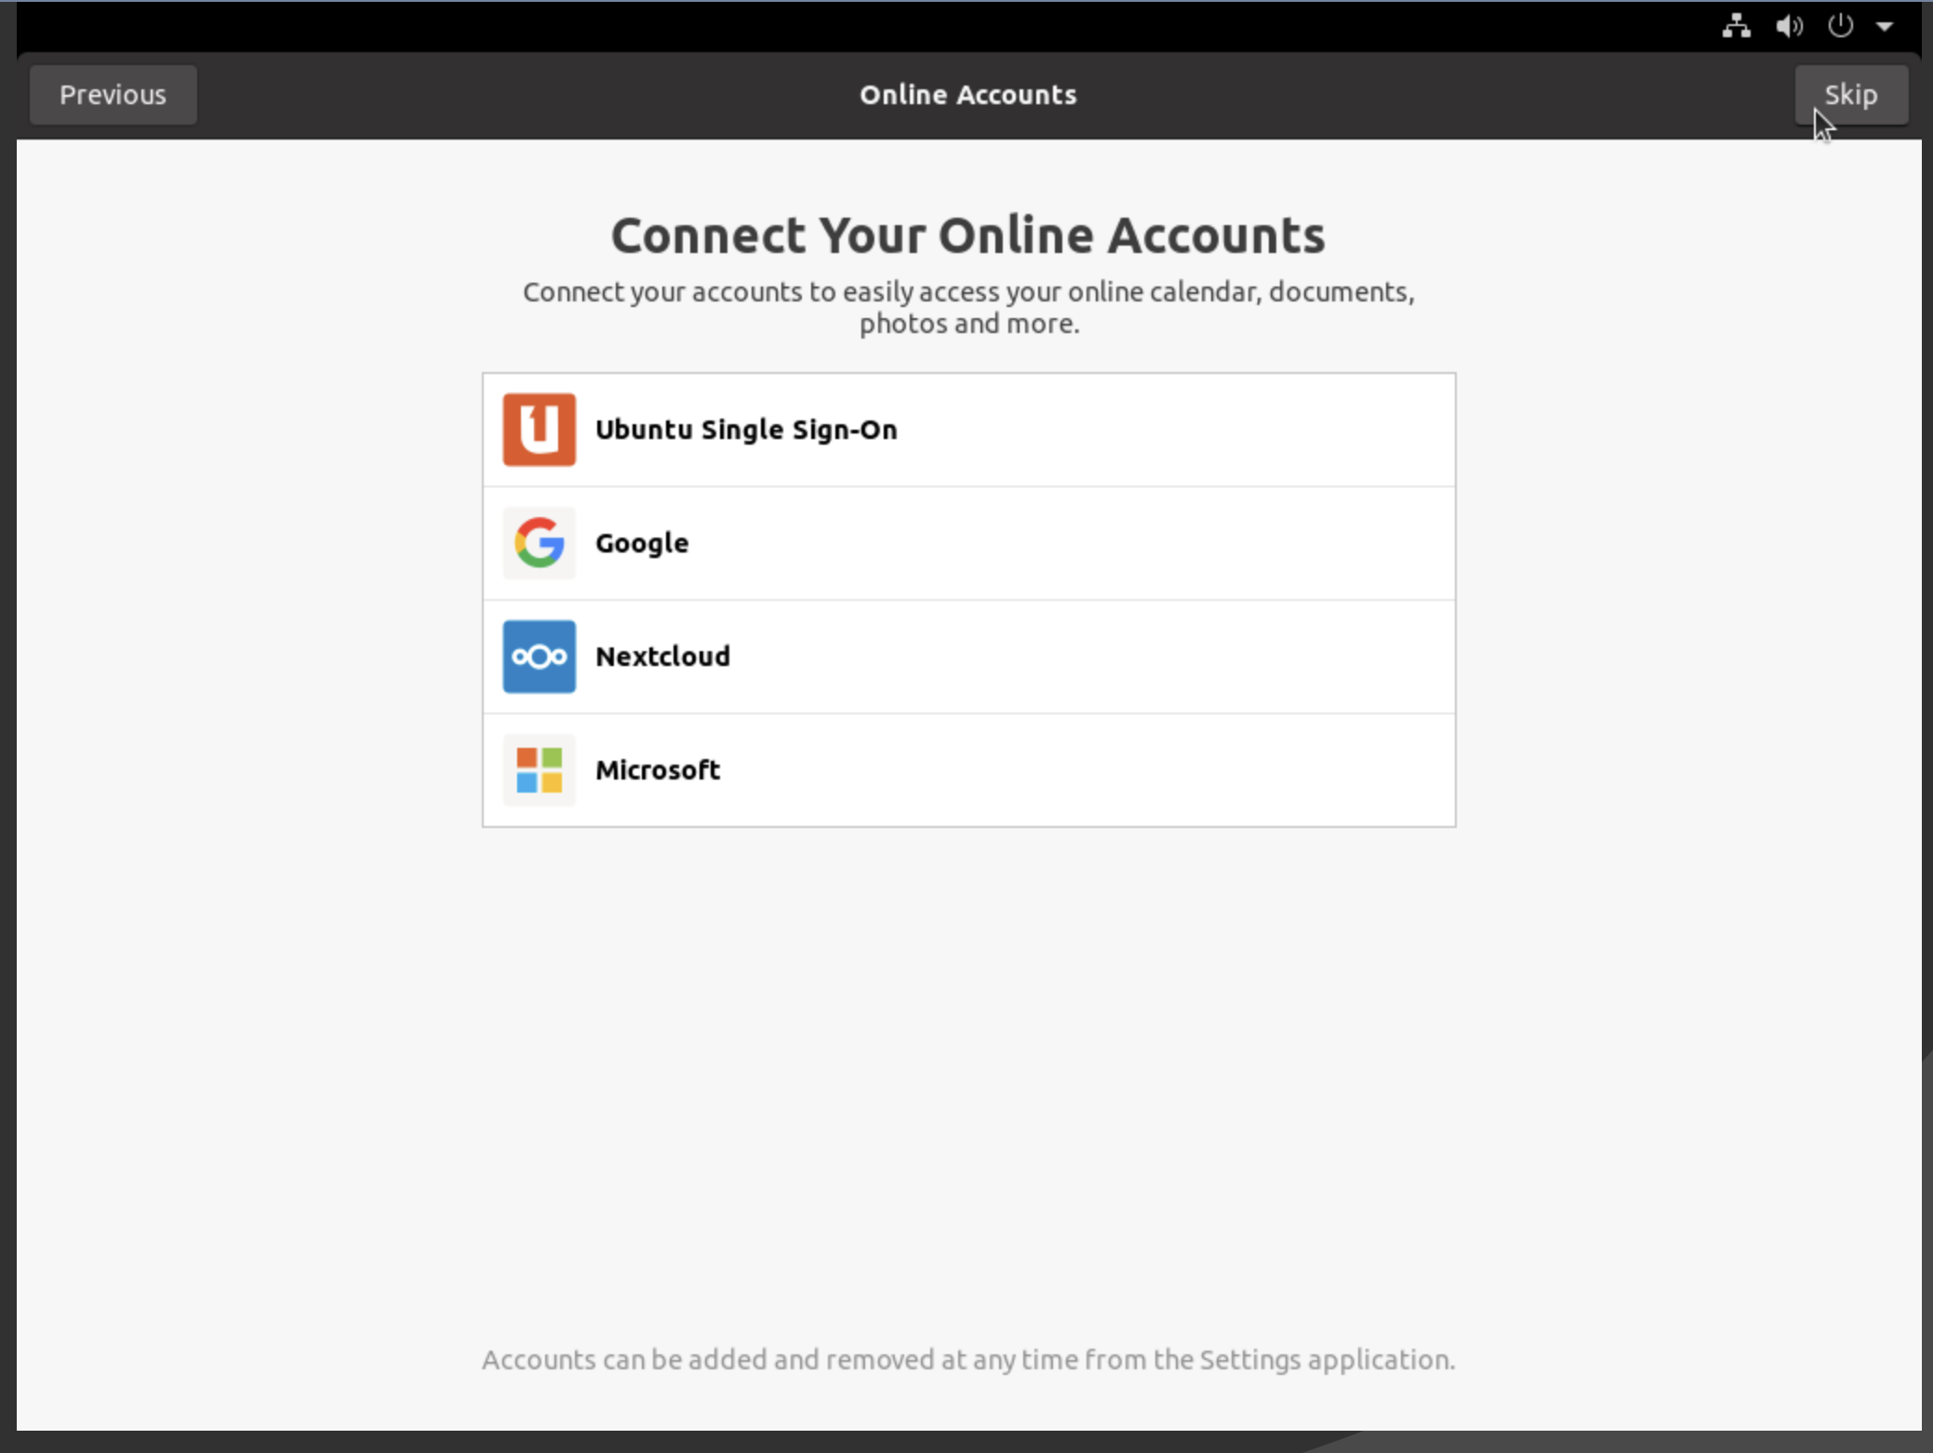
2. Create a user account. [This is different from the root account]

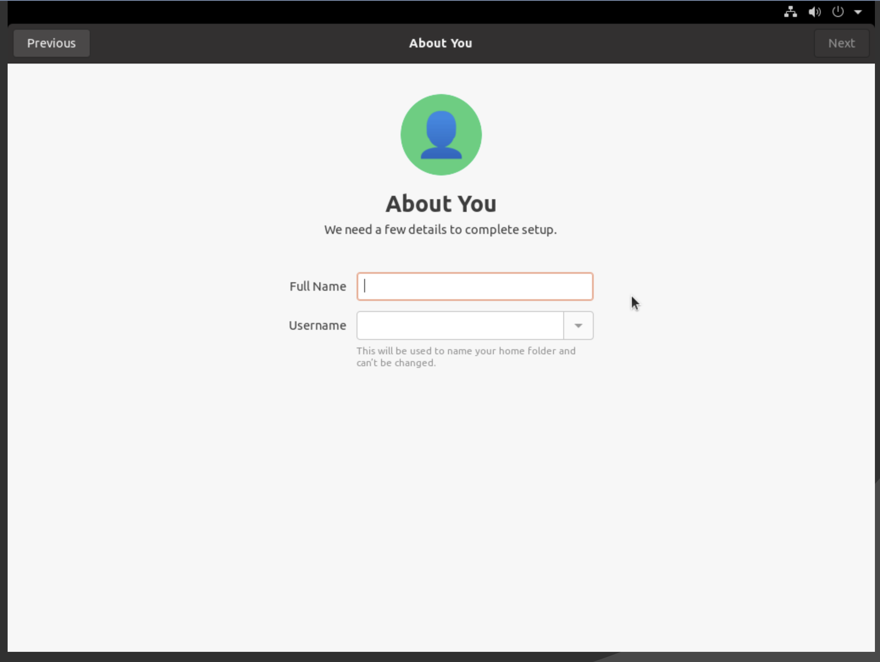

1. Set a password

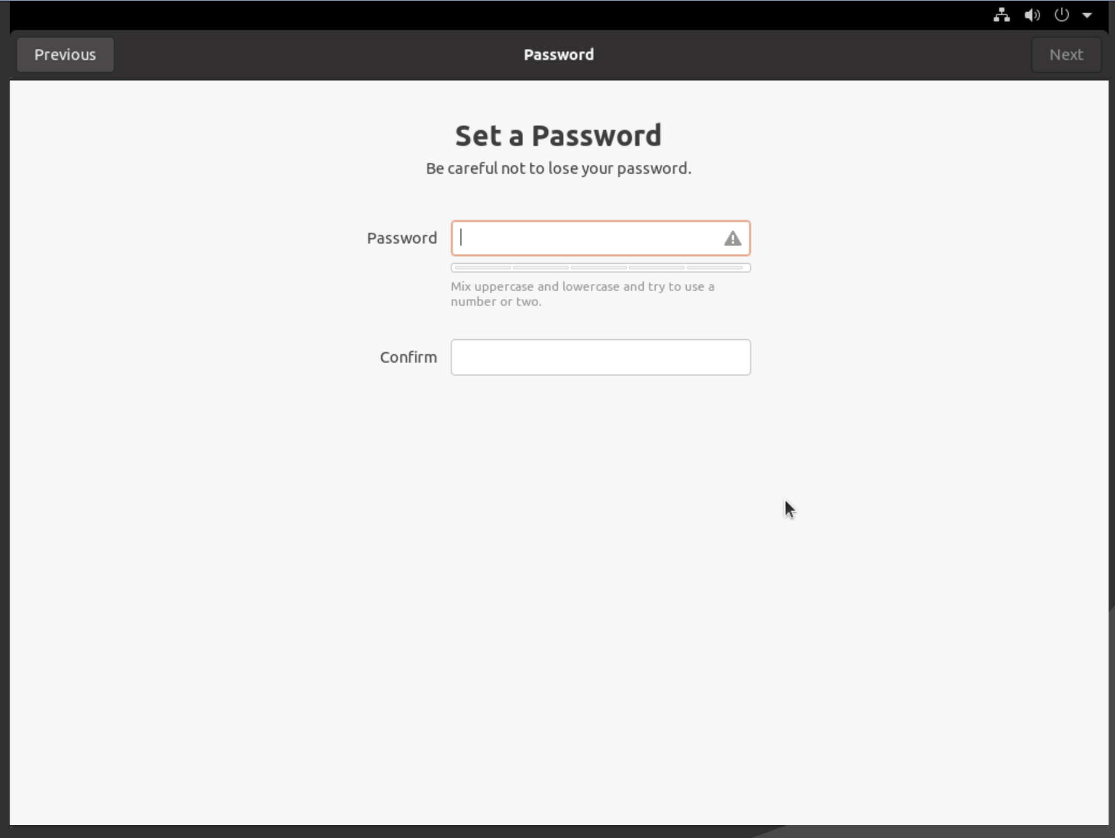

1. Click on “Start Using Ubuntu”

